Group Project
ST2 Assignment 2 – Group Project Report
Student Name: Ryan Lanzon
Unit Code: 7170
Tutorial: Tuesday 5:30 PM

1. Project Overview
The DSA Explorer & Visualiser is an interactive desktop application built using Python and the Pygame library.
- Module 1 – Data Structures Playground (Phase 1)
- Module 2 – Sorting Algorithm Visualiser (Phase 2)
- Module 3 – Graph Traversal Visualiser (Phase 2)
- Module 4 – Puzzle Challenges: A* Pathfinding & Event Queue Simulator (Phase 3)

2. Project Structure
- main.py – Main menu and module launcher
- data_structures.py – Stack, Queue, Linked List, BST visualisations
- sorting.py – Bubble Sort and Selection Sort with step-by-step animation
- graphs.py – BFS and DFS graph traversal with interactive node selection
- puzzles.py – A* Pathfinding puzzle and Event Queue Simulator
- test_dsa.py – Automated unit tests for all modules (27 tests)
To run the application: python main.py
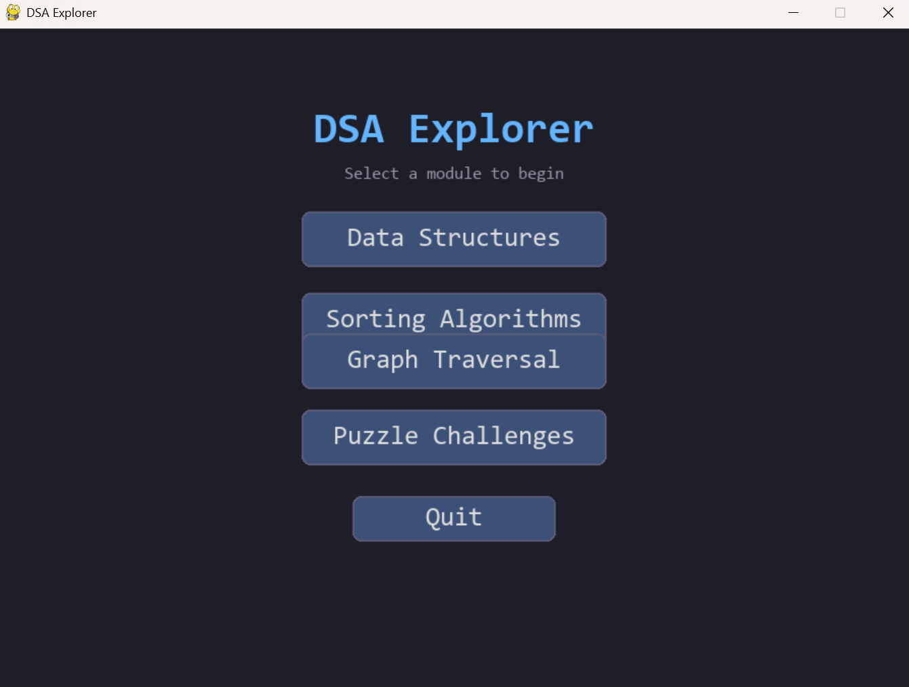

3. Phase 1 – Data Structures Playground

3.1 Stack
The stack is implemented using a Python list with LIFO. Users can push values onto the stack and pop them off. The top element is highlighted in green.

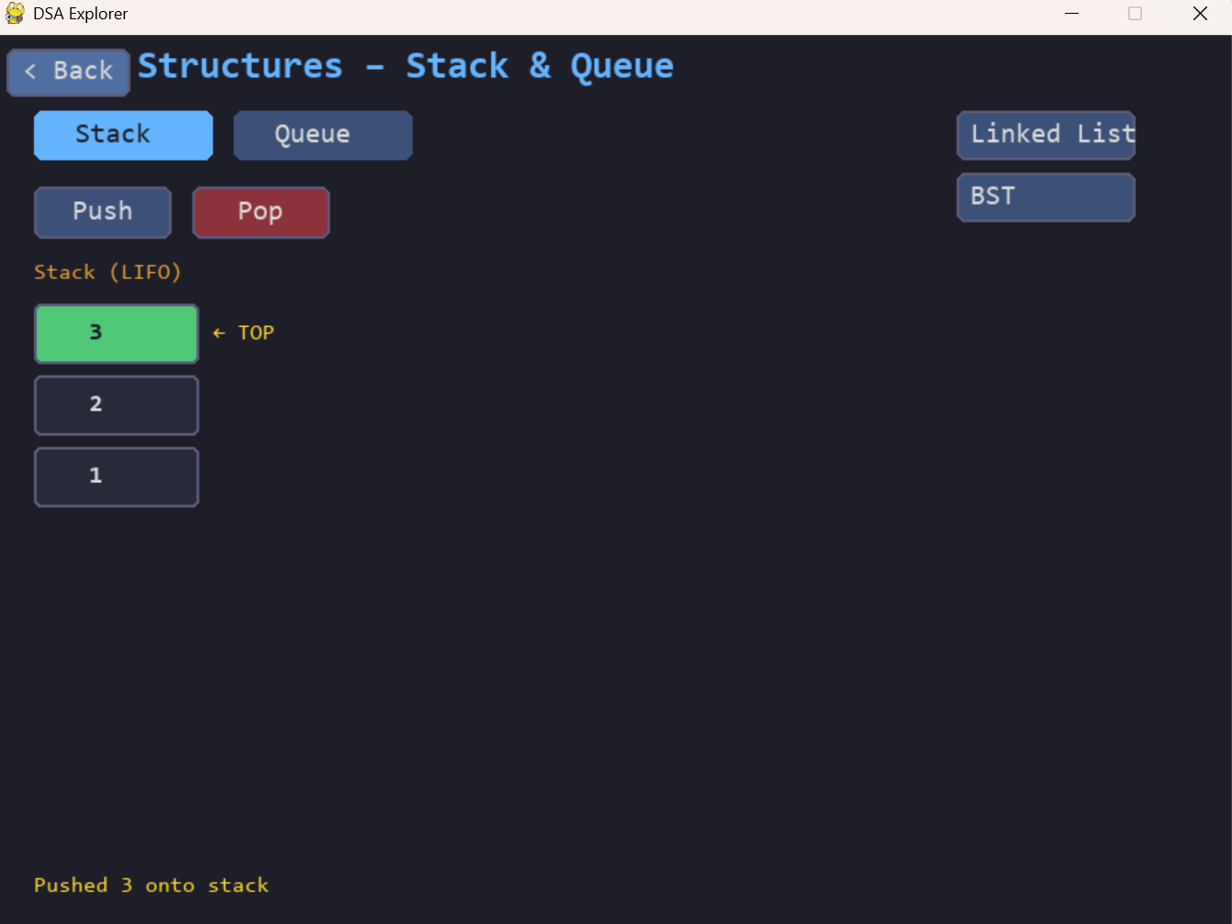

3.2 Queue
The queue uses a Python list with FIFO. Enqueue adds to the back, dequeue removes from the front. The front element is highlighted to indicate processing order.

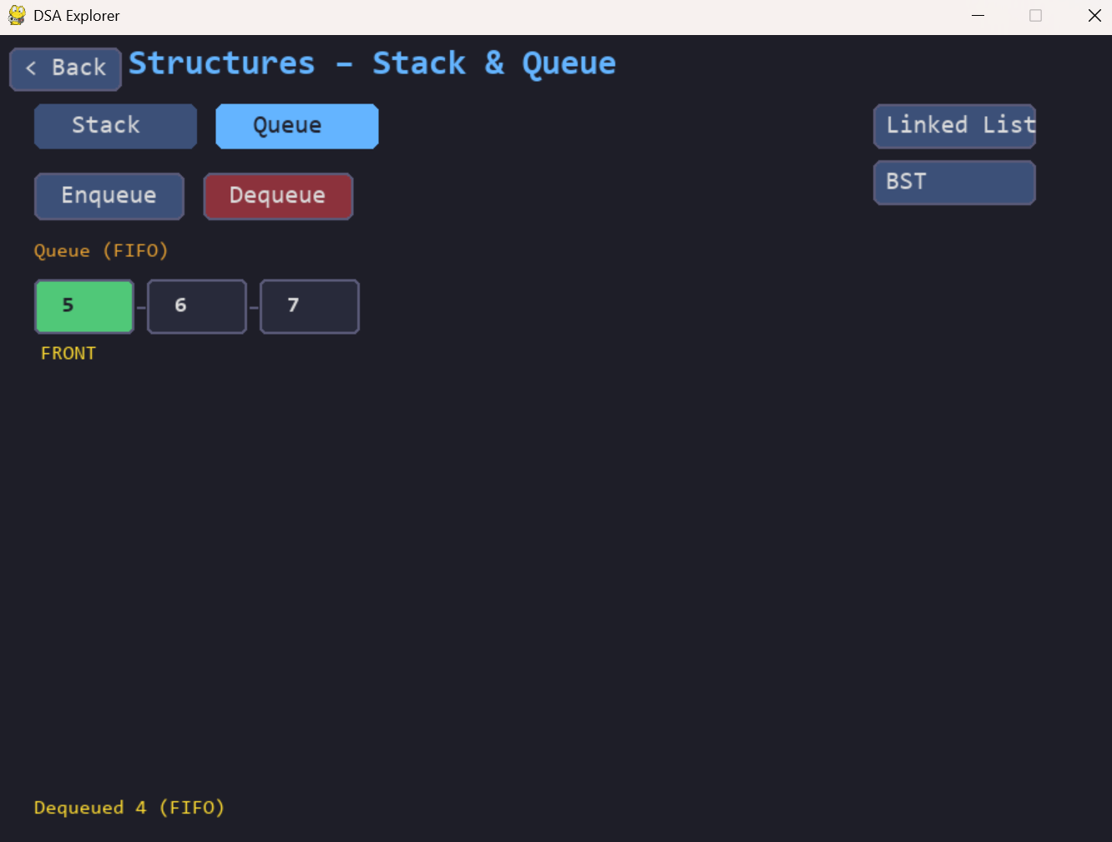

3.3 Linked List
Each node stores a value and a pointer to the next node. Actions are, insert at head, insert at tail, delete head, and reverse.

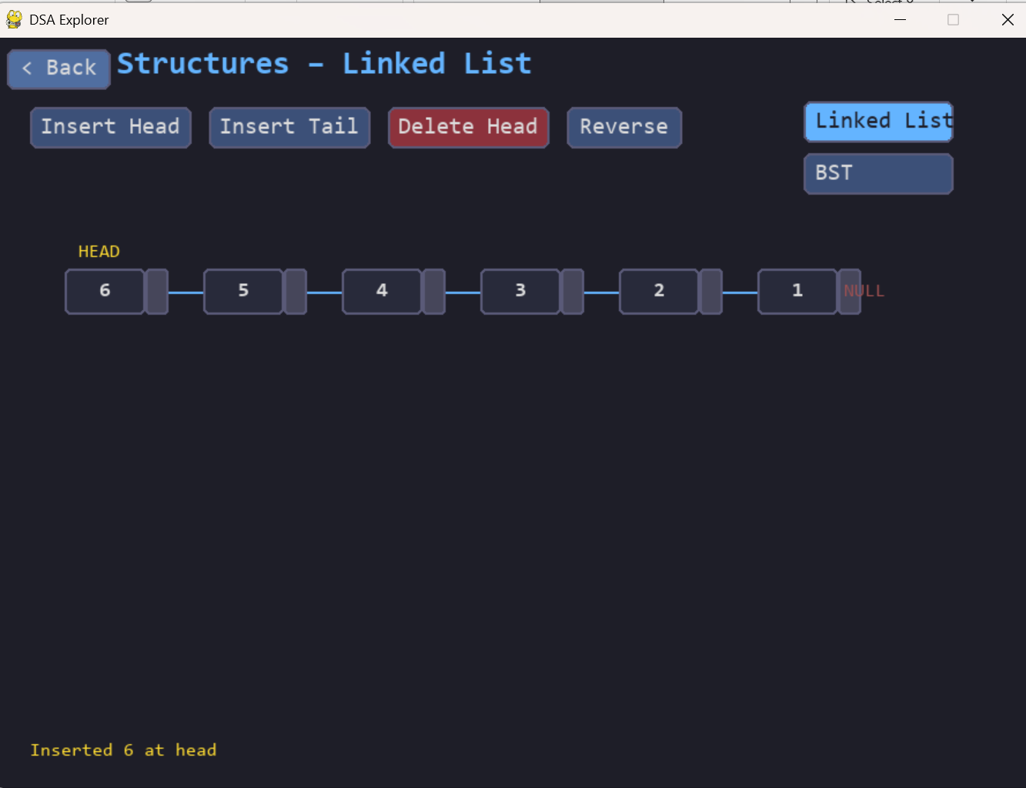

3.4 Binary Search Tree (BST)
Be able to insert nodes one at a time and can trigger inorder, preorder, or postorder traversal. The traversal result is displayed at the bottom. Inorder traversal always produces sorted output.

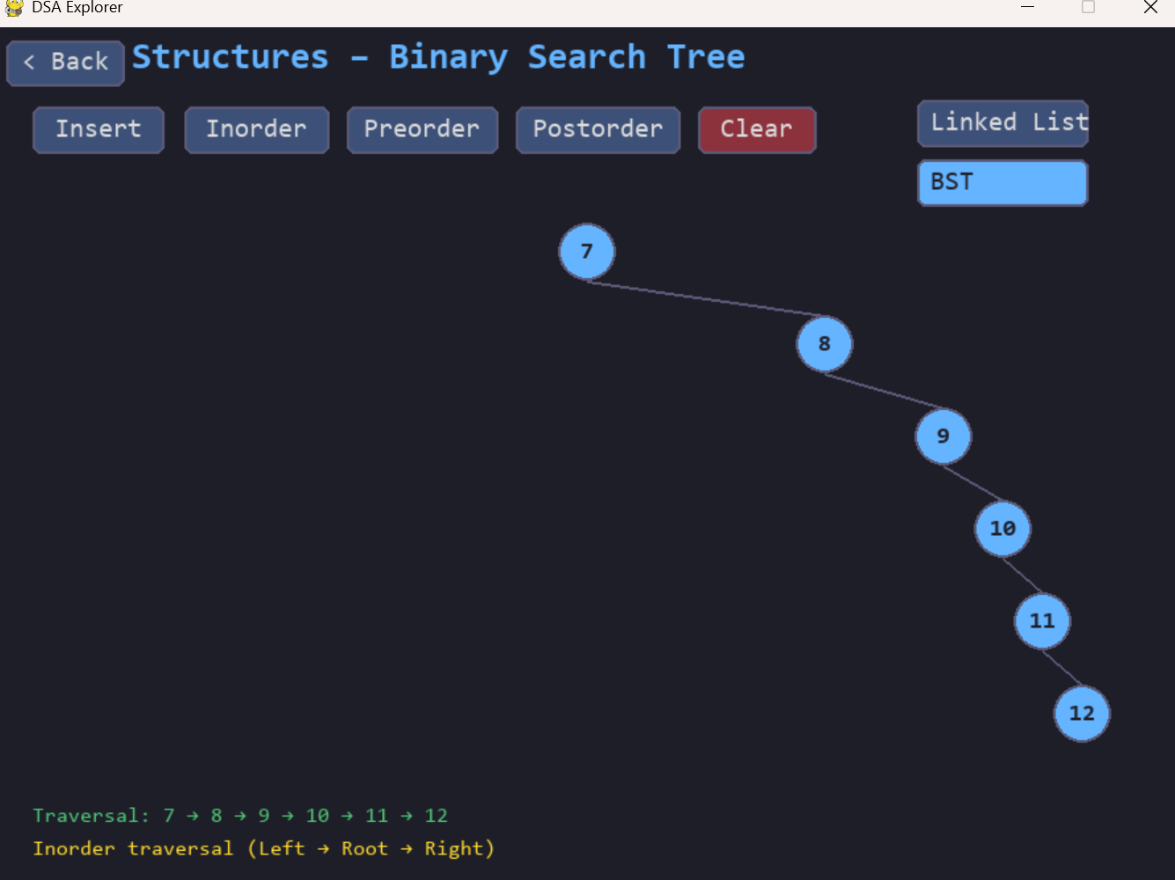

4. Phase 2 – Sorting Algorithm Visualiser
Randomly generated array of 18 integers (range 5–100). Each step is
- Blue – Unsorted element
- Orange – Elements being compared
- Red – Elements being swapped
- Green – Sorted element

4.1 Bubble Sort
Compares adjacent pairs and swaps them if out of order. Repeats until no swaps occur. The sorted portion grows from right to left, highlighted in green.

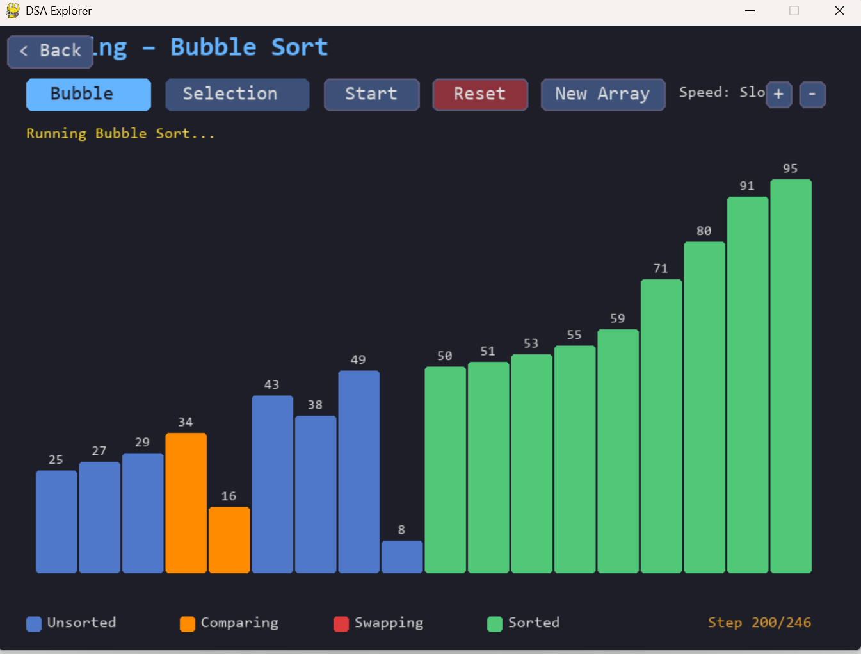

4.2 Selection Sort
Finds the minimum element in the unsorted portion each pass and places it at the front. The sorted portion grows from left to right.

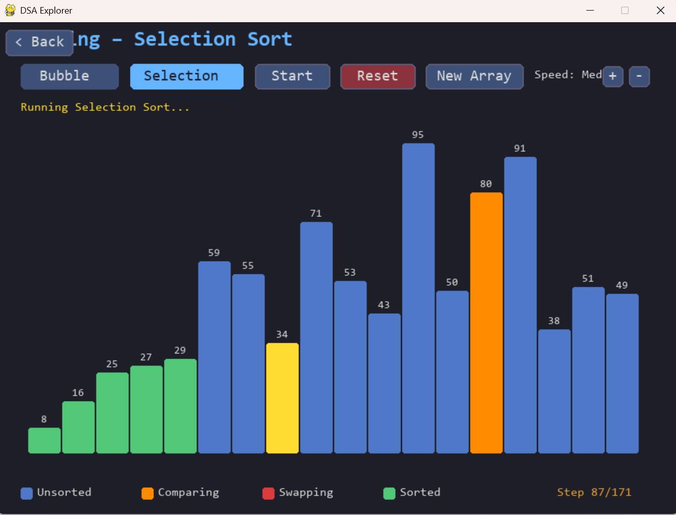

5. Phase 2 – Graph Traversal Visualiser
This module visualises BFS and DFS traversal on an 8-node undirected graph
- Red – Start node
- Yellow – Currently processing
- Purple – In queue/stack
- Green – Visited

5.1 BFS
The user can click any node on the graph to set it as the start node.

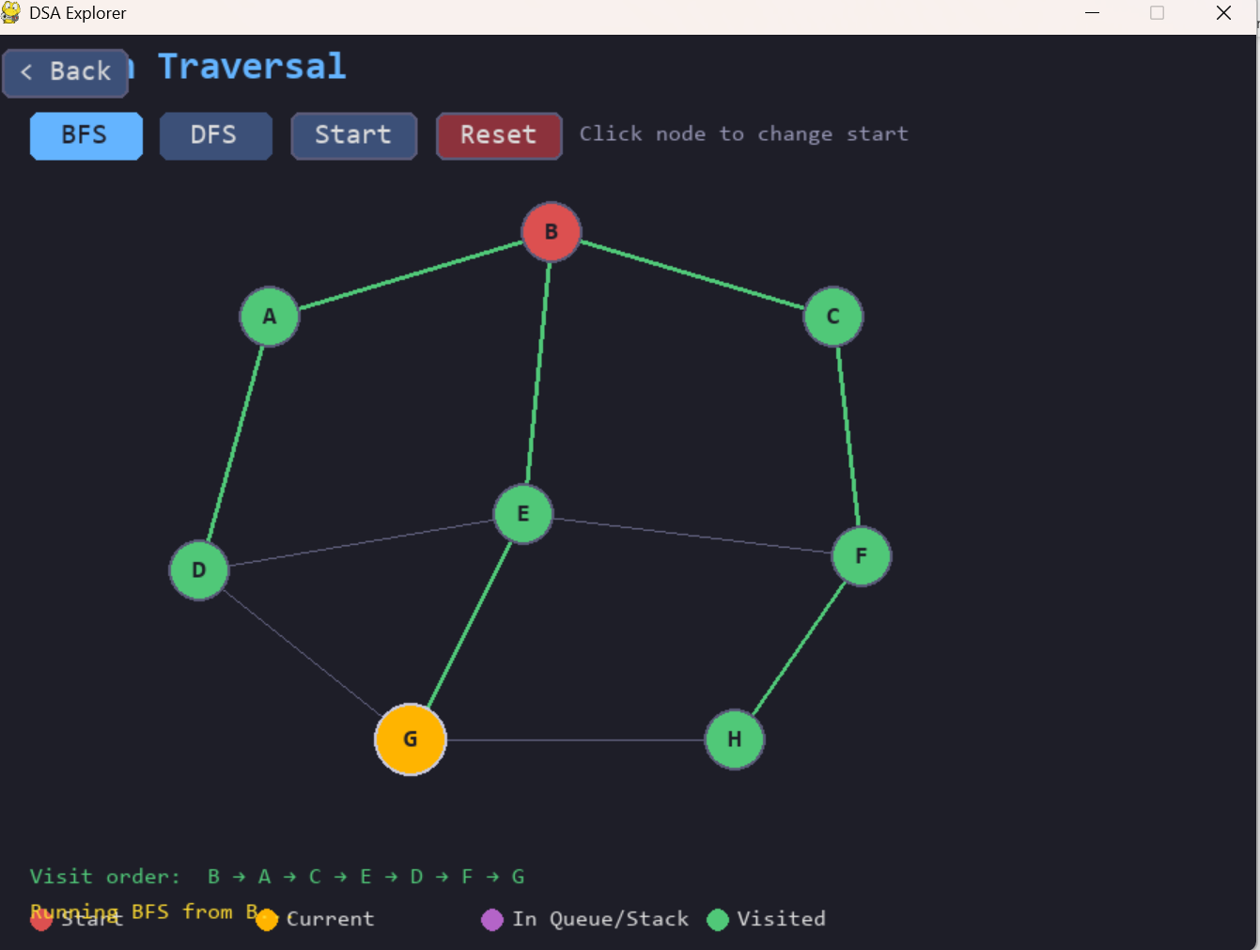

5.2 DFS
DFS uses recursion to go as deep as possible along one branch before backtracking.

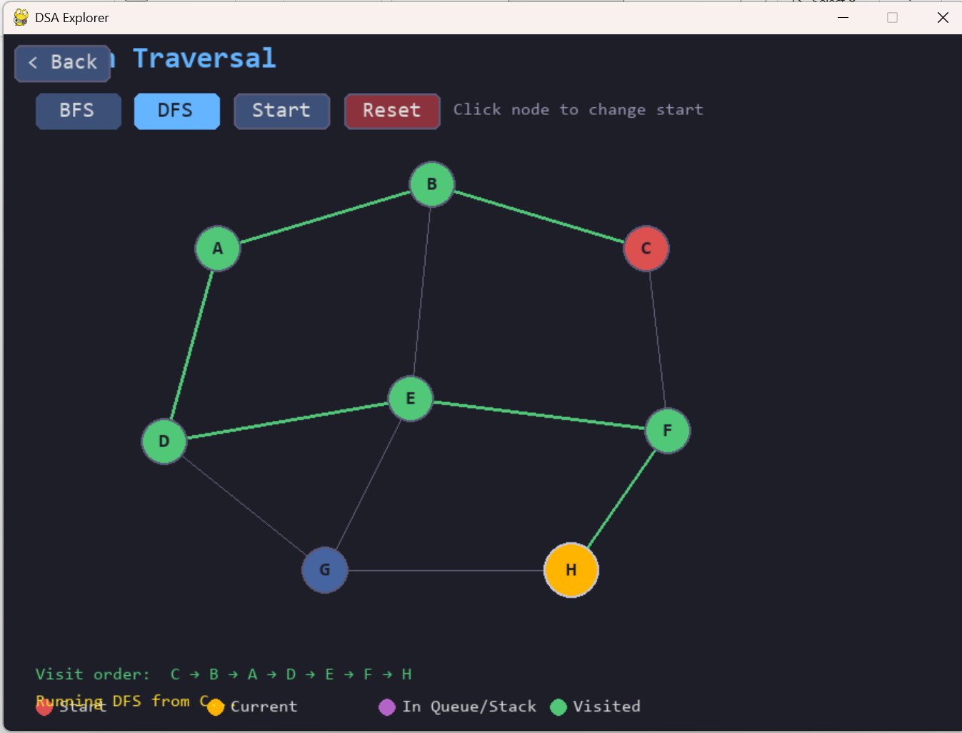

6. Phase 3 – Puzzle Challenges

6.1 A* Pathfinding Puzzle
Users interact with a 20x28 grid to place walls, set a start point and end point, then run the A* algorithm to find the shortest path.
- Red – Start cell
- Green – End cell
- Dark – Wall
- Blue – Open set (being considered)
- Dark Blue – Closed set (already evaluated)
- Yellow – Final path

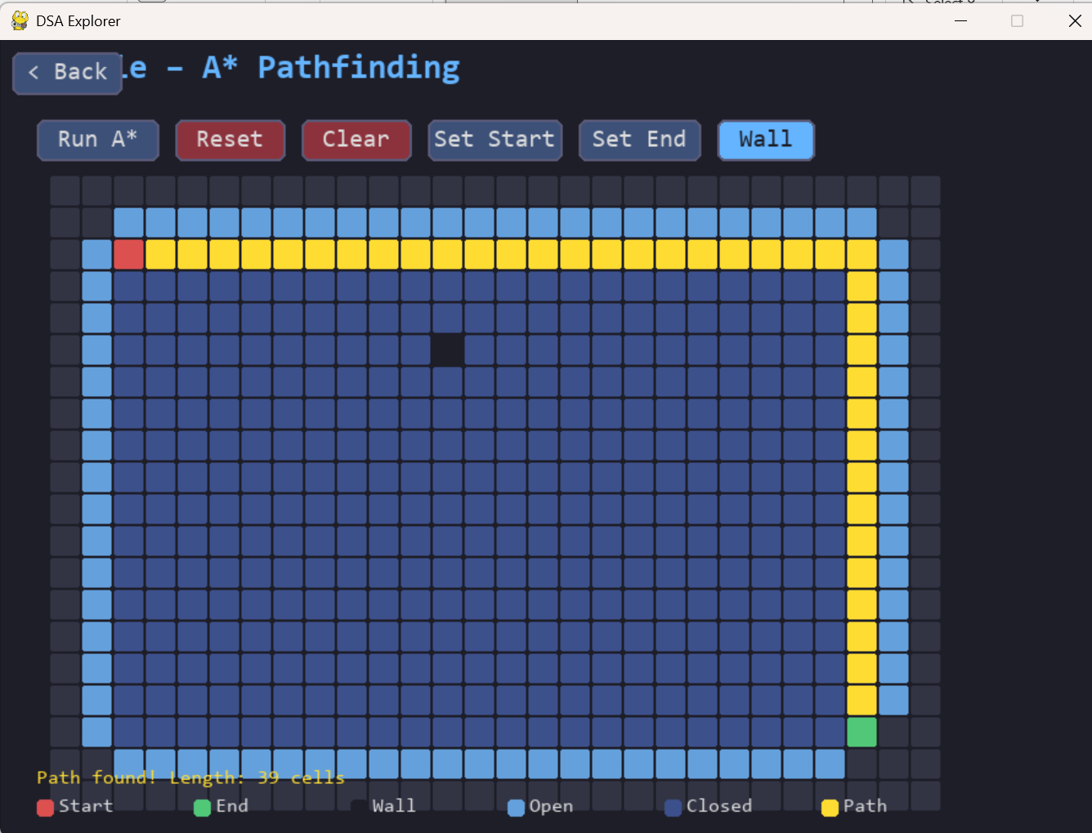

6.2 Event Queue Simulator
Simulates a priority-based event processing system using a min-heap.

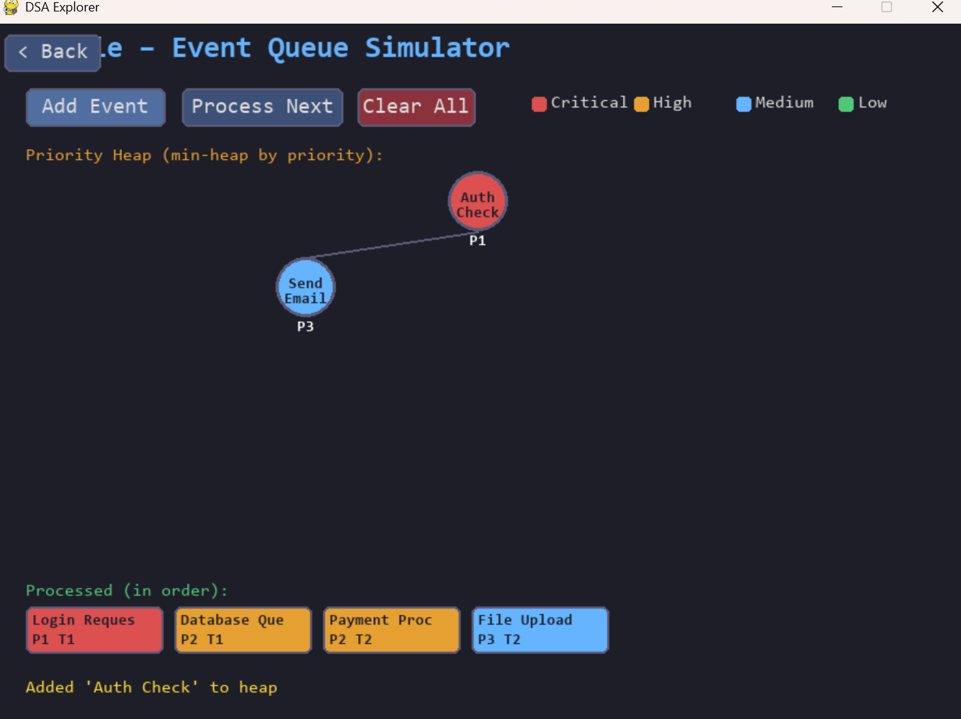

7. Automated Testing

7.1 Module 1 – Data Structures Test Plan

Test Case | Description | Expected Result
Stack push/pop sequence | Push 3 items, pop 2 | Final stack size = 1, correct LIFO order
Queue enqueue/dequeue | Enqueue 4 items, dequeue 3 | FIFO order maintained
Linked list insertion at pos | Insert node with value 10 at position 2 | Node present in correct location in list
BST insert and inorder traversal | Insert [50,30,70]; inorder traversal | Traversal order: 30, 50, 70

7.2 Module 2 – Sorting Test Plan

Test Case | Description | Expected Result
Bubble sort correctness | Sort array of [5,3,8,1,2] | Sorted array: [1,2,3,5,8]
Selection sort animation | Ensure colours highlight compared elements | Highlight changes each step correctly

7.3 Module 3 – Graph Traversal Test Plan

Test Case | Description | Expected Result
BFS traversal from 'A' | Visit nodes reachable from 'A' | Nodes visited in correct BFS order
DFS traversal from 'C' | DFS order matches expected path | Traversal path matches theoretical DFS
Interactive start node | Clicking different nodes | BFS restarts correctly from chosen node

7.4 Module 4 – Puzzle Test Plan

Test Case | Description | Expected Result
A* finds path on empty grid | Run A* from (0,0) to (5,5) | Path found and returned
A* no path when blocked | Wall off destination row | Empty path returned
Event priority order | Push Critical P1 and Low P4 events | P1 processed first
Same priority time order | Two P2 events at different times | Earlier time processed first

